IT PAT 2023:

Phase 1:

1A- Scenario and Scope:
The environment of the Earth is collapsing. With the unsustainable use of resources mass deforestation and the heating of the environment is occurring. However this can be alleviated by implementing sustainable practices such as green technology and recycling. Green technology is not widely available yet and the sale thereof is limited to developed countries with the resources to do so.

The problem is to design a software system that eases the distribution and sale of green technologies. My solution to this is to design an online store that retails green technologies such as solar panels, air-based water capture systems, energy-efficient appliances and LED lights. This eases the distribution of more environmentally friendly technologies as potential customers will have a more convenient way of purchasing these technologies. This will increase adoption and decrease the effects of human action on the environment.

The scope of this project is thus to develop an online store based on Delphi that uses Access relational databases and a Delphi-based web server. The project will not support payment methods such as card payments or EFT but will rather use a simulacrum of that. Users will be able to create accounts and the accounts will remember their ‘purchase’ history. The interface of the project will consist of a series of HTML pages that are stored on the web server.

1B- User Requirements:

Name | Requirements
Customer | - Will buy the product  - Browse products offered  - Limited to only see products offered and their orders/ history
Supplier | - Supplies products to the store  - Limited to only see their products and amounts,
Admin | - See everything  - No limitations

2- Database design:

Customer Table:
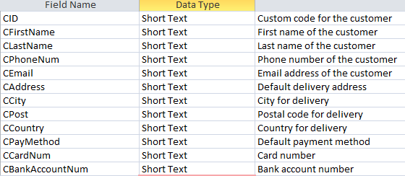

Order table:
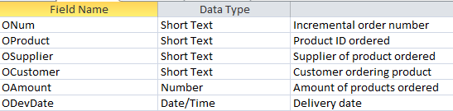

Product table:
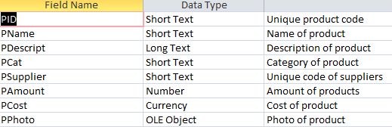

Supplier table:
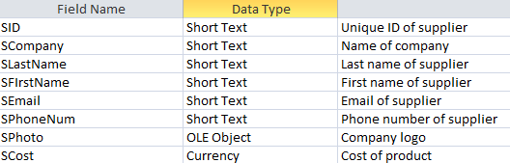

Relationships:
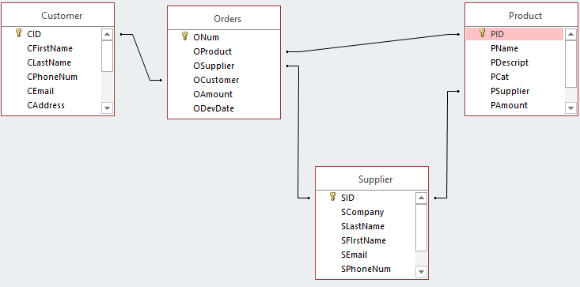

3A- Classes and objects:
TProduct
- fName: string
- fCat: string
-fAmount: integer
-fCost: Real
+ <<constructor>> Create(sName, sCat: String; iAmount: Integer; rCost: Real)

GetName: String
GetCat: String
GetAmount: Integer
GetCost: String
SetAmount
SetCost

TSupplier
- fLastName, fFirstName, fEmail, fPhoneNum: string
+ <<constructor>> Create(sFirstName, sLastName, sEmail, sPhoneNum: String)

+ getFirstName: String
+ getLastName: string
+ getEmail: string
+ getPhoneNum: string
+ setFirstName
+ setLastName
+ setEmail
+ setPhoneNum

TProduct and TSupplier will be used to simplify the process of displaying information about the products and suppliers. Creating objects for this will also simplify the process of changing their details as a procedure can be called in stead of repeating multiple lines of code.

3B- Text files & other:
Text files be used as log files for the purchase history of products as well as the logon and logoff of users. This adds value to the application as it gives admins a clear overview of the activity of the site. It also adds security as admins will be able to see when users logged on and off it there is an incident.
Two arrays of objects will be used for both the suppliers and products.

4A- Flow Diagram:
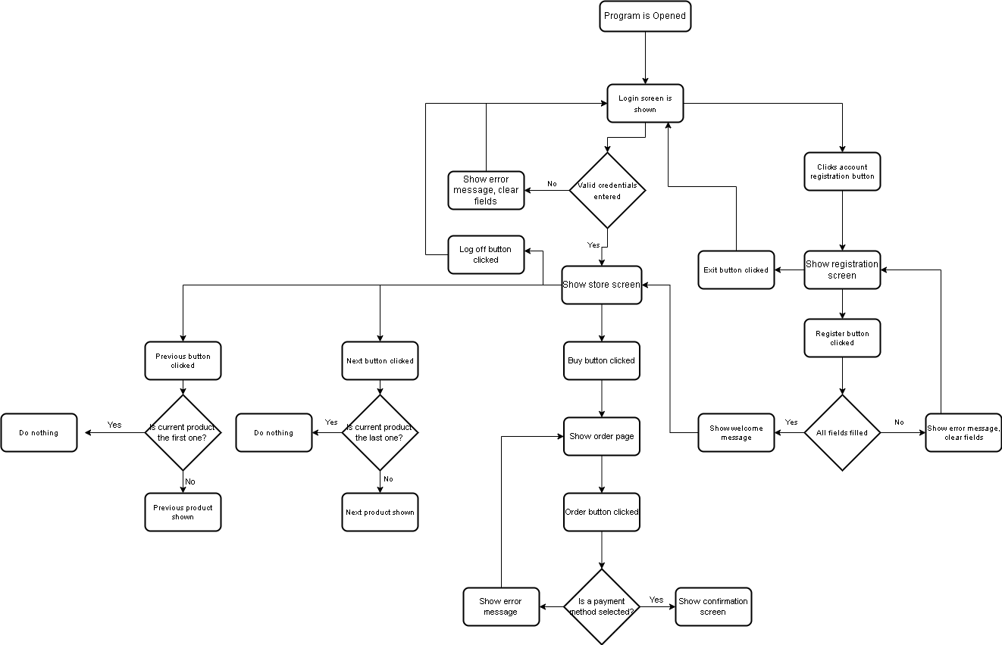

4B- GUI Design:

Login Page:
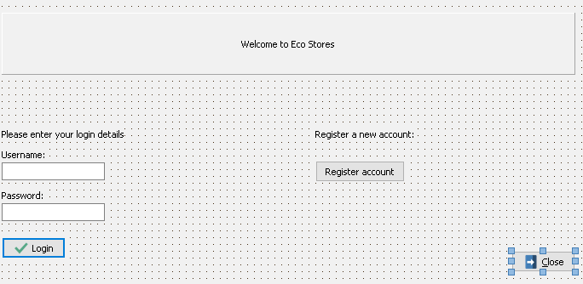

Store Page:
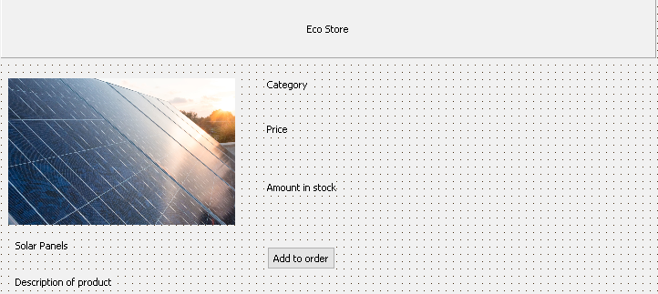

Account registration page:
